Al Kabash Alasseel ( Weight Scale Project )

Requirements
- 7 Digit Barcode
- 5 Digit Weight
- 1 Digit Check sum

For this requirements have to assign the Self Define Code Option.
- Go to Software Select the Self-define Barcode
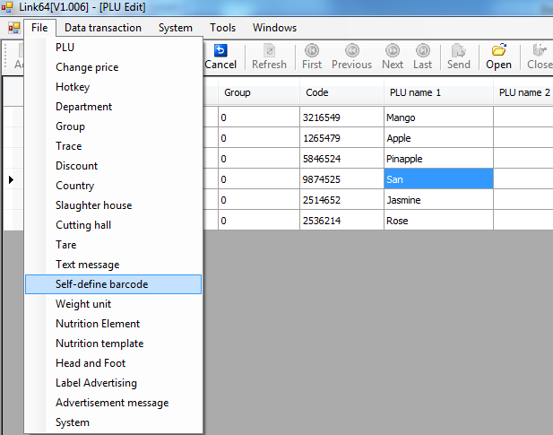

- And Select this Options And Send to Device.
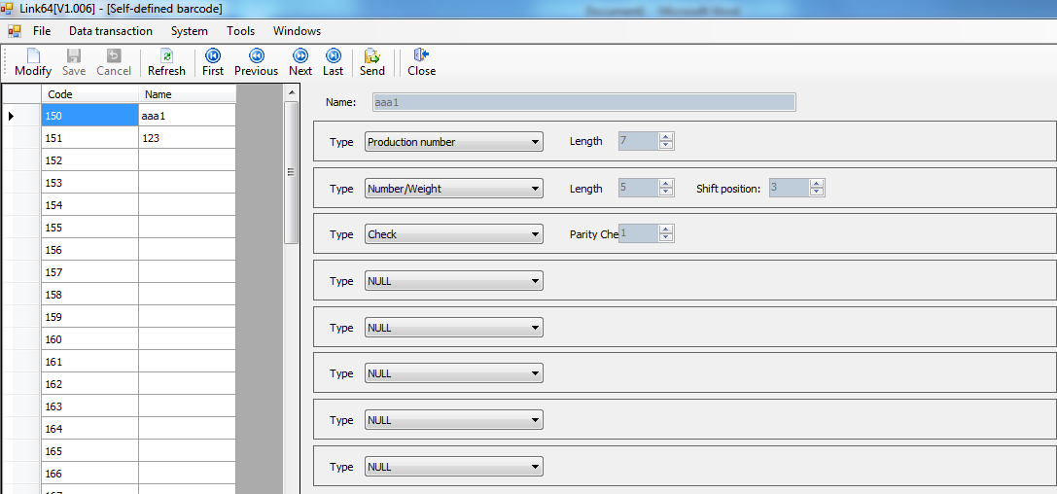
- Select Batch Edit
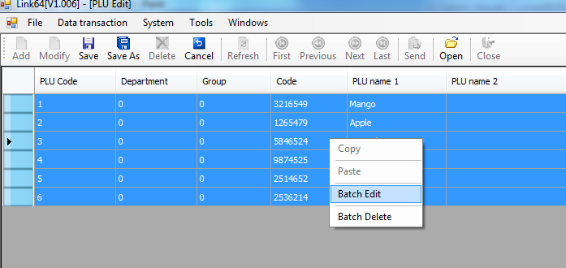

- Select Barcode Type 150
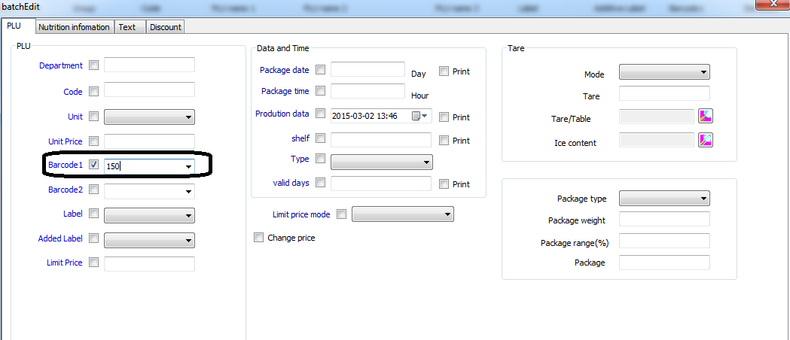 And Send it In Device

Regards Customer Name
Kapil
Technical Support
69029771

Project Finished

Technical Manager Sign

